How Q Replication Replicates Very Large Database Transactions with Low Latency - Tips for using Q Replication with a Db2 Data Warehouse

By Serge Bourbonnais and Weiqiang Zhuang, IBM Silicon Valley laboratory.

Posted July 27th, 2026


Summary
Db2 Version 12.1.4 introduces a new Q Apply option, ‘INTRA_TRANS_COMMIT’ that dramatically improves end-to-end replication latency for very large database transactions particularly for row-organized tables.

Introduction
Q Replication is a software-based log capture and asynchronous transaction replay technology available with the IBM InfoSphere Data Replication (IIDR) product. It serves as the integrated replication technology for IBM Db2 on Cloud and IBM Power 10 Private Cloud Rack for Db2 Warehouse.

Q Replication replicates transactions between active databases for both OLTP and analytics workloads, supporting both Db2 column-organized and row-organized tables.

Q Replication delivers low-latency database transaction replication (seconds) across continental distances (thousands of kilometers) for thousands of tables and high-volume data changes (billions of row changes per day).

Q Replication is commonly used to maintain near real-time active copies of application data for:
- Application continuous availability and disaster recovery
- Workload distribution
- Data proximity across geographies
- Test and development on live copies, such as ad-hoc queries

For most use cases, replicated data must maintain latency of seconds or at most a few minutes to provide value.

Q Replication can replicate transactions of any size and has been optimized to replicate very large transactions on column-organized tables by leveraging External Table operations for transaction replay.

However, until now, Q Replication could not consistently replicate very large transactions on row organized Db2 tables with sufficiently low latency, limiting its scope for row-organized Db2 Data warehouses.

The Challenge with Replicating Large Transactions on Data Warehouses
In a data warehouse, large amounts of data often must be ingested or transformed daily for analysis. Industry best practices recommend applying changes in smaller unit of work (transactions) to enable greater execution parallelism, minimize excessive memory and disk usage, and prevent lock contention and escalations.

However, very large transactions cannot always be avoided
- Organization may lack control over applications loading data into the data warehouse.
- Modifying applications may be deemed too disruptive or costly to implement

Large transactions can update, delete, or insert billions of rows
and gigabytes of data before committing changes. Such transactions
strain system resources and challenge replication technologies.

How Q Replication Handles Very Large Transactions Today.
First, let's take a look at the Q Replication process:

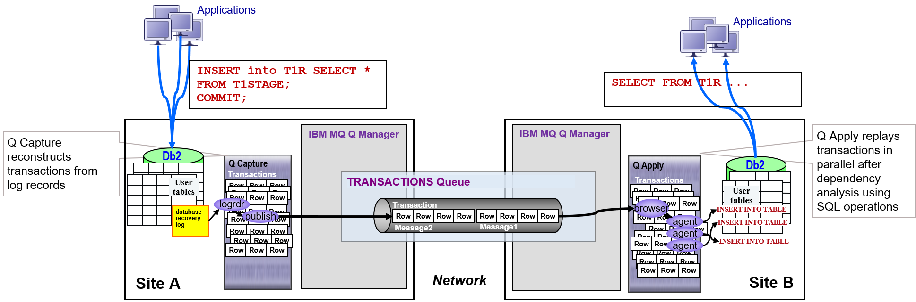

The Q Replication Process:
A transaction is captured from the Db2 logs by reading log records. When its COMMIT log record is processed, the transaction is complete. Modified data is transmitted over the network using persistent IBM MQ queues, then reconstructed and applied at the target database using the SQL interface.

The replication process guarantees resiliency throughout failures. Any component can be shut down and restarted, resuming replication from the point of interruption.

Capture Spilling: Typically, the Capture process reads all log records for a transaction and buffers them in memory until the commit is reached. When a transaction exceeds available memory, Q Capture handles this by spilling log records to files for processing them when the final commit is reached. This enables the Capture program to replicate transactions several gigabytes in size with only a few hundred megabytes of memory.

Apply Monster Transaction Mode: At the target, the Apply program typically reads entire transactions into memory and applies all non-dependent transactions in parallel. When a transaction is too large to fit in memory, Q Apply disables parallelism and applies the transaction chunk by chunk, serially over a single database connection. This allows Q Apply to process transactions modifying gigabytes of data with only a few megabytes of memory.

The Replication Performance Bottleneck:
The primary end-to-end replication bottleneck is in replaying transactions at the target database through the SQL interface. Performance is constrained because a transaction must be replayed over a single database connection.

While the DBMS provides inter-transaction parallelism across multi-core systems, this is less effective than the parallelism achievable by distributing the transaction across multiple database connections that can be independently optimized.

Q Apply V12.1.4 addresses this limitation with a new parameter: INTRA_TRANS_COMMIT.

How Does Q Apply INTRA_TRANS_COMMIT Work?
Q Apply:
- Breaks large transactions into sub-transactions
- Applies sub-transactions in parallel --after dependency analysis
- Replicates the large transaction with eventual consistency
- Guarantees the large transaction integrity is restored following a failure or outage

Trying out Q Apply INTRA_TRANS_COMMIT

INTRA_TRANS_COMMIT is a receive queue-level parameter on the Q Apply side. To try it out, modify an existing QMAP to set INTRA_TRANS_COMMIT=2 — this is the optimal value for most workloads. Q Capture should be running with the default MAX_MESSAGE_SIZE of 64KB.

To activate the change, update the receive queue control table directly on the Q Apply side and then recycle Q Apply. In the code snippet below, the source database is SRCDB and the target database is TRGDB; the schema for both Q Capture and Q Apply is ASN on both sides
# connect to the TARGET database
db2 “connect to TRGDB”
# Update the receive queue on the target side
db2 “update ASN.IBMQREP_RECVQUEUES set INTRA_TRANS_COMMIT=2”
# Restart Q Apply
asnqapp apply_server=TRGDB apply_schema=ASN

If needed, change the Q Capture MAX_MESSAGE_SIZE for the send queue at the source side:
# connect to the SOURCE database
db2 “connect to SRCDB”
# Update the send queue at the source side
db2 “update ASN.IBMQREP_SENDQUEUES set MAX_MESSAGE_SIZE = 64”
# Restart Q Capture
asnqcap capture_server=SRCDB capture_schema=ASN

As an alternative, you can create a new QMAP using the asnclp scripting language:

CREATE REPLQMAP "QMAP1" USING
ADMINQ “ASN.ADMINQ"
RECVQ "QMAP1.RECVQ"
SENDQ "QMAP1.SENDQ"
MAX MESSAGE SIZE 64 INTRA TRANS COMMIT 2;

Out-of-the-box Performance Test Results
The following results are not intended as a formal benchmark — improvements will vary depending on workload characteristics and hardware configuration. However, results were consistently positive across all configurations and workloads tested, with end-to-end latency improvements of up to 40x in the best case. The results below are for Q Replication connecting remotely over Db2 client connections

Live Workload | Baseline (Apply in monster mode) |  | intra_trans_commit=2  multi_row_inserts=Y |  | Improvement
 | End-to-End Latency | Throughput | End-to-End Latency | Throughput
inserts | 46m55s | 14,461 rows/sec | 3m | 242,424 rows/sec | 16x
updates | 48m06s | 14.149 rows/sec | 3m43s | 240,000 rows/sec | 17x
delete | 48m25s | 13,802 rows/sec | 2m56s | 248,447 rows/sec | 17x

These results demonstrate that the bottleneck lies in applying transactions to the target system — precisely the problem that INTRA_TRANS_COMMIT is designed to address. In all test runs, Q Capture accounted for less than 2% of the total end-to-end latency, even when spilling log records to disk after its memory was exhausted. An Apply-side bottleneck is the common pattern reported by Q Replication customers.

Summary

The performance benefit of INTRA_TRANS_COMMIT will vary with workload characteristics and hardware configuration, but the option has delivered consistently positive results across all tests conducted to date.

Combined with other recent Q Replication enhancements – including Q Capture transaction spilling for Db2 Warehouse workloads that include both row-organized and column-organized tables and Q Apply’s support of Db2 MULTI_ROW_INSERTS – INTRA_TRANS_COMMIT completes the set of capabilities that directly address the needs of customers whose workloads involve very large transactions on row-organized tables.

This option is available for Q Replication on the distributed platform (LUW) with Db2 V12.1.4.

The Authors
Serge Bourbonnais is the Lead Architect for IBM Q Replication.
Weiqiang Zhang is the Lead Developer for IBM Q Replication.
Both are based at the IBM Silicon Valley laboratory in San Jose, California

